**Assignment -1**

Python Programming

|  |  |
| --- | --- |
| Assignment Date | 19 September 2022 |
| Student Name | SUBHIKSHAA S |
| Student Roll Number | 111519104153 |
| Maximum Marks | 2 Marks |

**Question-1:**

**Split this string**

|  |
| --- |
| **Solution:** |
| s = "Hi there Sam!”  print(s.split()) |
|  |
|  |
|  |
|  |
|  |
| #----------------------------------------# |
| #----------------------------------------# |
|  |  |

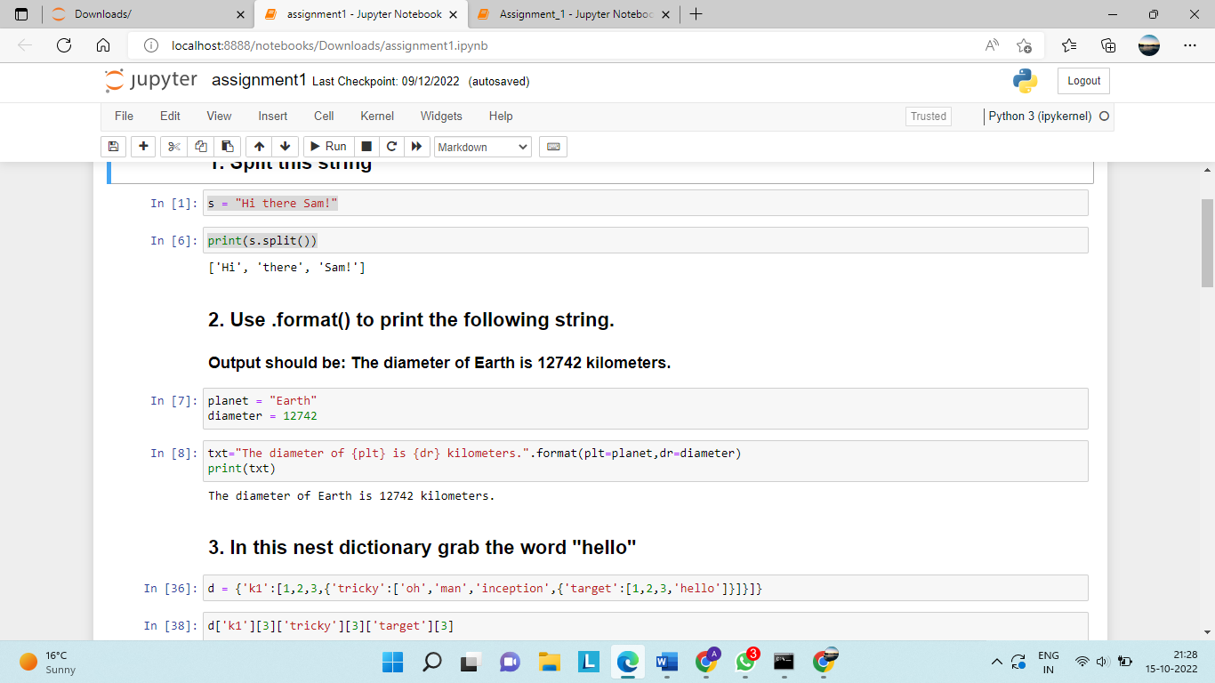

**Question-2:**

## Use .format() to print the following string.

## Output should be: The diameter of Earth is 12742 kilometers.

|  |
| --- |
| **Solution:** |
| planet = "Earth"  diameter = 12742  txt="The diameter of {plt} is {dr} kilometers.".format(plt=planet,dr=diameter)  print(txt) |
|  |
|  |
|  |
|  |
|  |
|  |
| #----------------------------------------# |
| #----------------------------------------# |

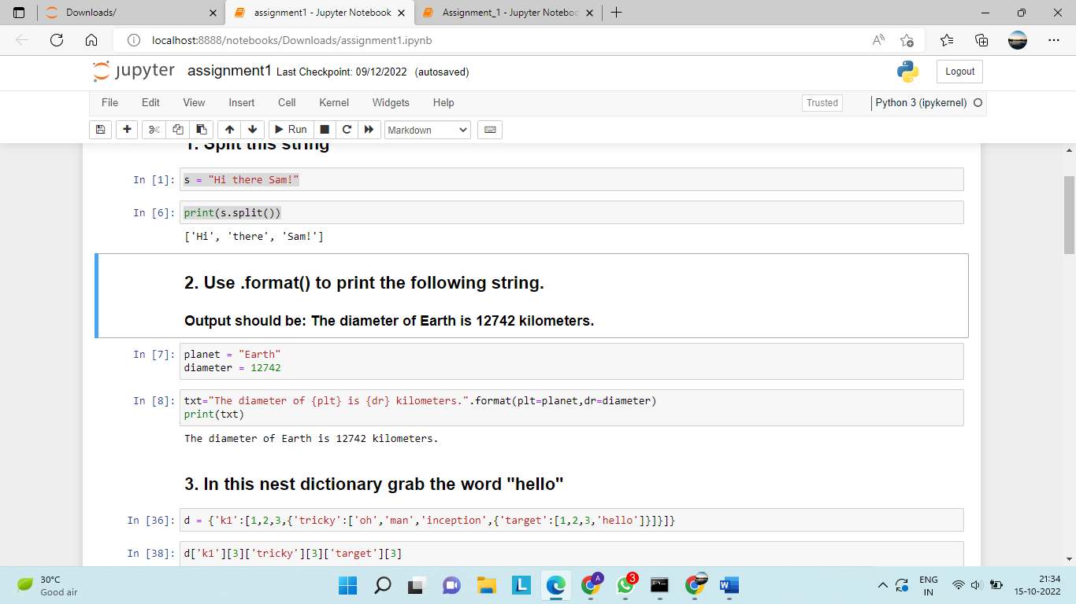

## Question-3:

## In this nest dictionary grab the word "hello"

## d = {'k1':[1,2,3,{'tricky':['oh','man','inception',{'target':[1,2,3,'hello']}]}]}

**Solution:**

print(d['k1'][3]['tricky'][3]['target'][3])

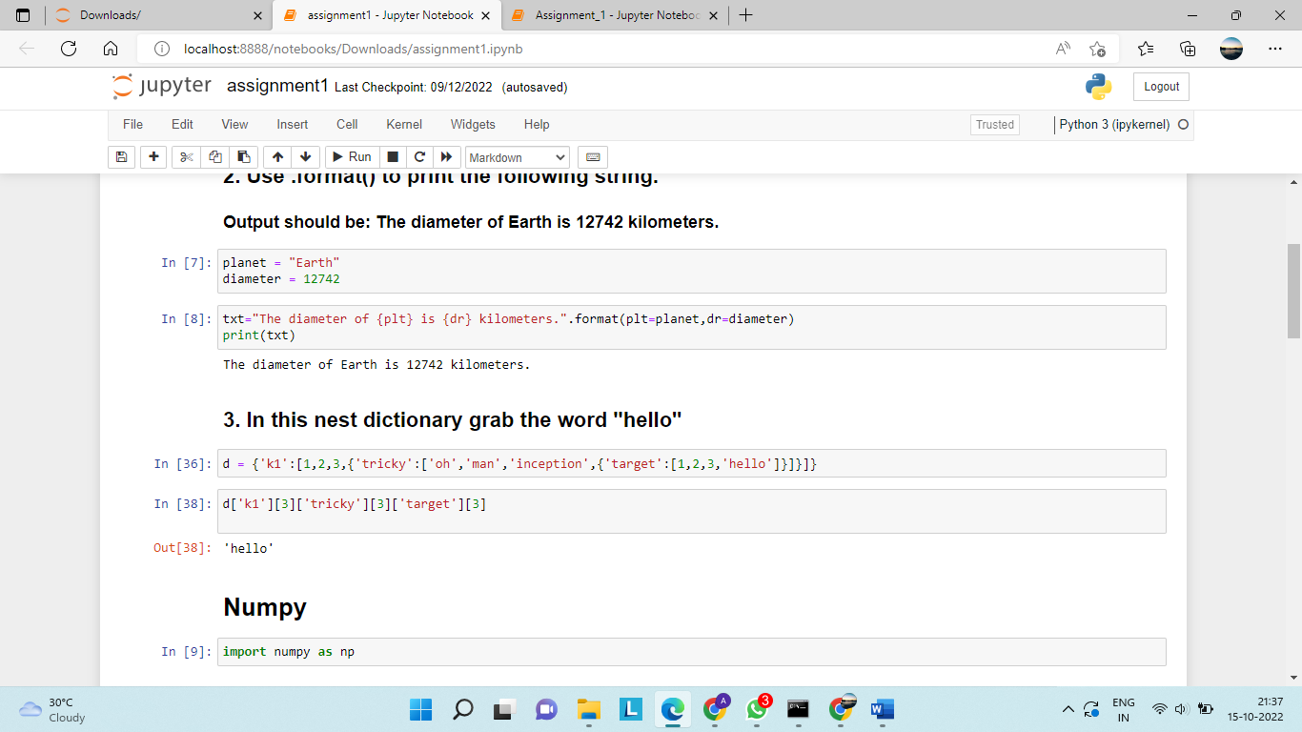

## Question-4:

# Numpy:

import numpy as np

## 4.1 Create an array of 10 zeros?

## 4.2 Create an array of 10 fives?

**Solution:**

## 4.1 array=np.zeros(10)

## print(array)

4.2 array=np.ones(10)*5

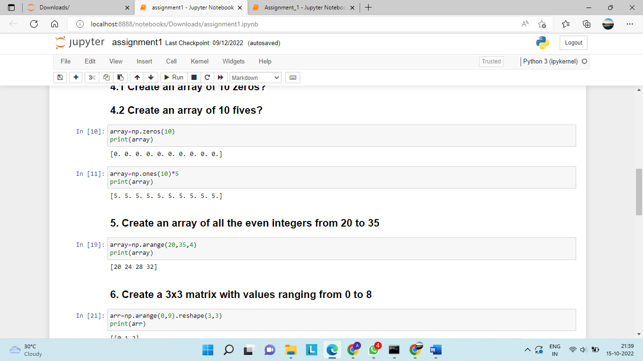 print(array)

## Question-5:

## Create an array of all the even integers from 20 to 35

## import numpy as np

**Solution:**

## array=np.arange(20,35,4)

## print(array)

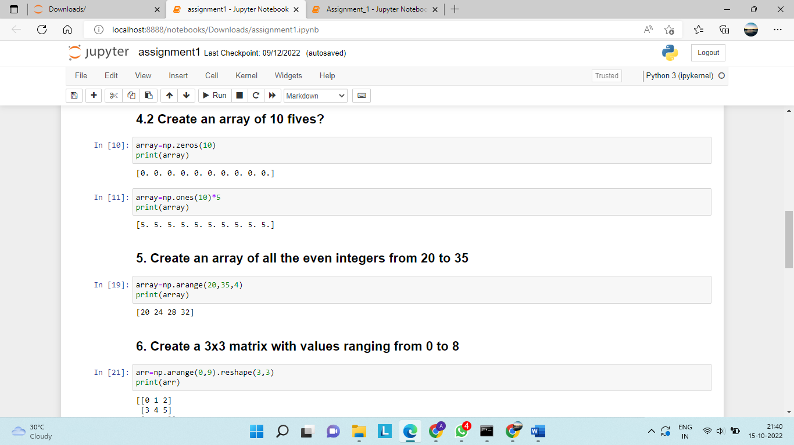

## Question-6:

## Create a 3x3 matrix with values ranging from 0 to 8

## import numpy as np

**Solution:**

array=np.arange(0,9).reshape(3,3)

print(array)

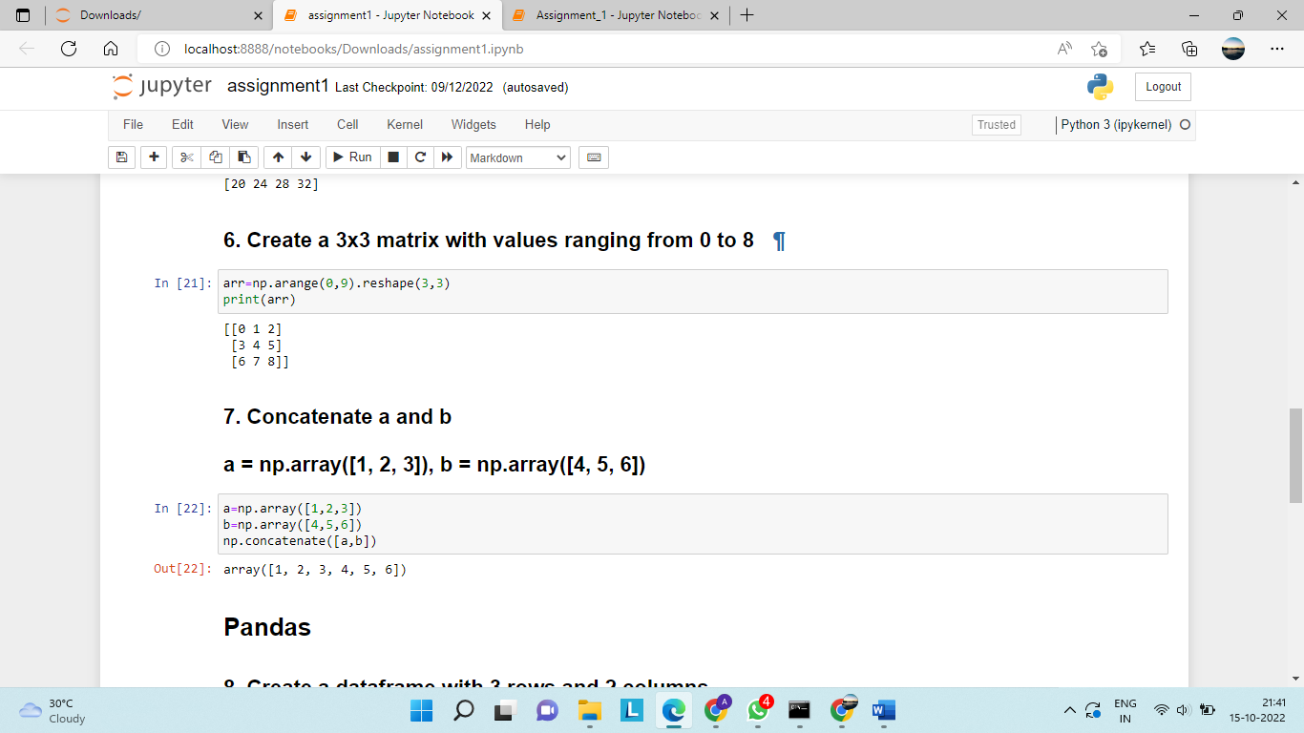

## Question-7:

## Concatinate a and b

## a = np.array([1, 2, 3]), b = np.array([4, 5, 6])

**Solution:**

## a=np.array([1,2,3])

## b=np.array([4,5,6])

## print(np.concatenate([a,b]))

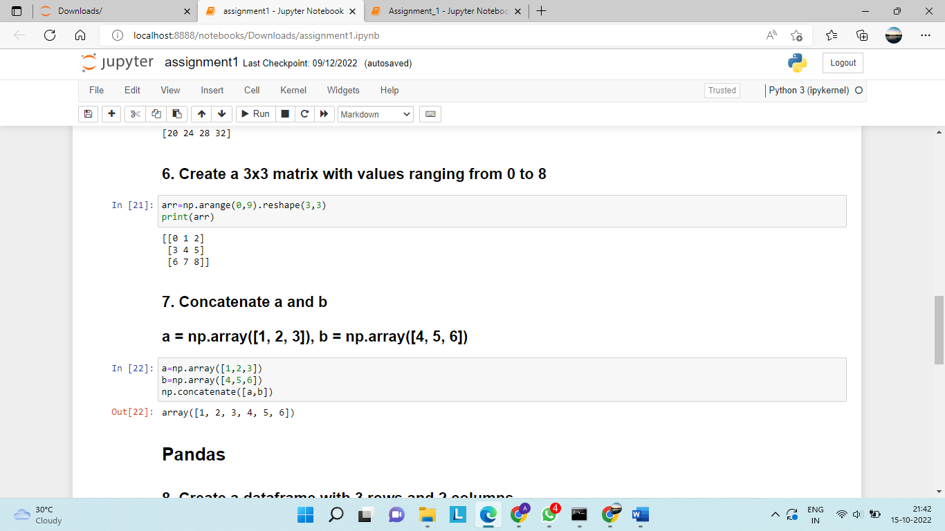

## Question-8:

## Create a dataframe with 3 rows and 2 columns

## import pandas as pd

**Solution:**

## import pandas as pd

## import numpy as np

## data=pd.DataFrame(index=np.arange(3), columns=np.arange(2))

## print(data)

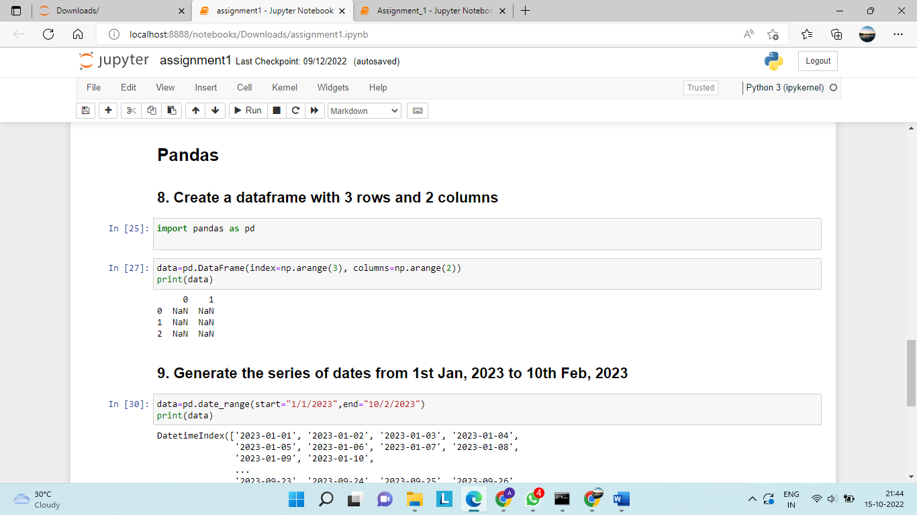

## Question-9:

## Generate the series of dates from 1st Jan, 2023 to 10th Feb, 2023

**Solution:**

data=pd.date_range(start="1/1/2023",end="10/2/2023")

print(data)

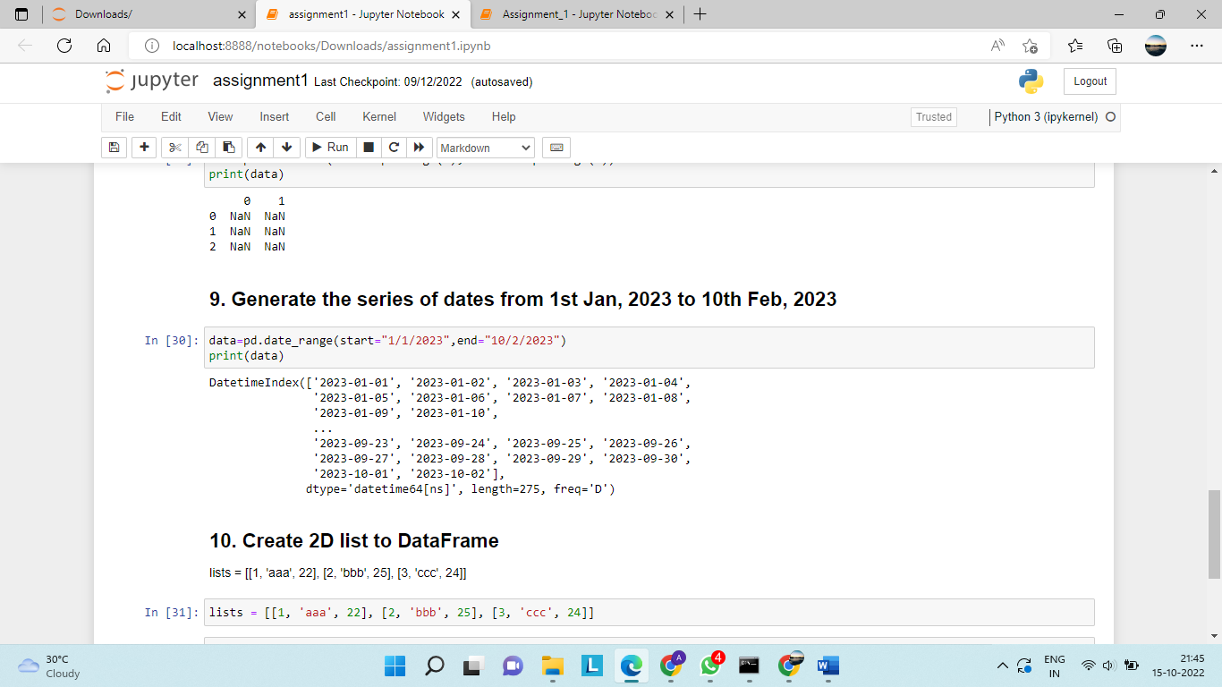

## Question-10:

## Create 2D list to DataFrame

lists = [[1, 'aaa', 22], [2, 'bbb', 25], [3, 'ccc', 24]]

**Solution:**

data=pd.DataFrame(lists,columns=["s.no","pattern","number"])

print(data)

